# EM108: Software Development

# Academic Year 2015-2016

# Exam Report

## Student Number: 15410402

## Class: CE1

## Exam Date: 14/04/2016

### Plan: Include Standard C Libraries

Define the “house” structure

Declare the list of functions

Write function to print a user menu and take user inputs to execute other functions

Write function to read values from the data file

Write function that computes the tax which is attributable to each house

Write function to print results to an output file

Write function that prints results to an on screen table.

Write the main function to give opening message, and to call all other functions.

### Development:

Development began with the introduction of the standard C libraries: stdio.h, stdlib.h, and string.h. From here the structure “house” was defined. The read_records function was then written, and added to the list of functions. This function contains a while loop, which reads through the data until the end of the file has been reached. It scans for the different variables contained in the house structure, and stores them in the array. Next, the compute_tax function was written and added to the function list. This function uses an “if, else” statement to compute the tax payable by each house, due to the values of that houses waste, area and water variables. The beginning of the main function was written, including the variables of “norecs” and “i”, which are used in loops throughout the program, and the program compiled to ensure there were no errors in these functions. From here, the write_records, and print_results functions were written, and again added to the list of functions. The program was again compiled and this time tested to ensure it was working correctly. The print_menu function was then written, added to the list of functions, and called in the main function. From the menu function, all other functions are called according to the users input.

Testing:

Testing was performed to ensure all aspects of the program were working correctly.

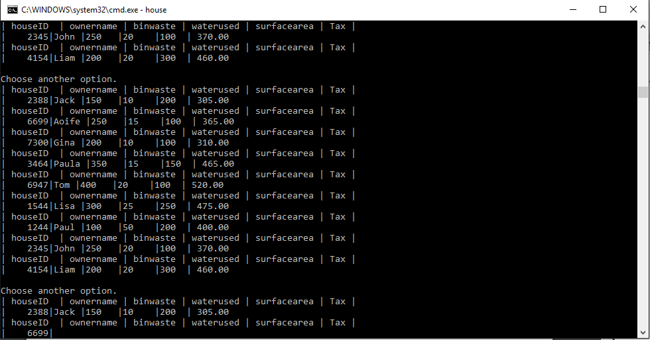Program incorrectly printing multiple times to both screen and file due to misplaced while loop.

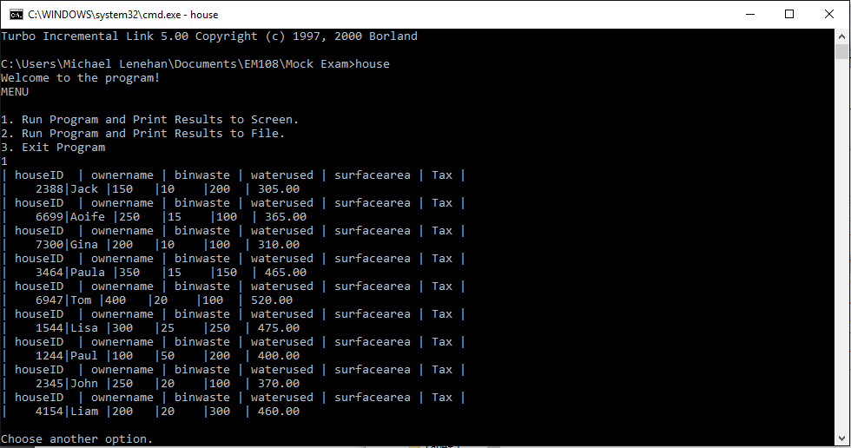Program correctly printing table

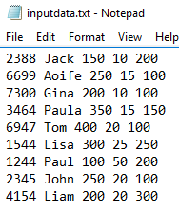Correctly Printing table to file.

Better Format of Table

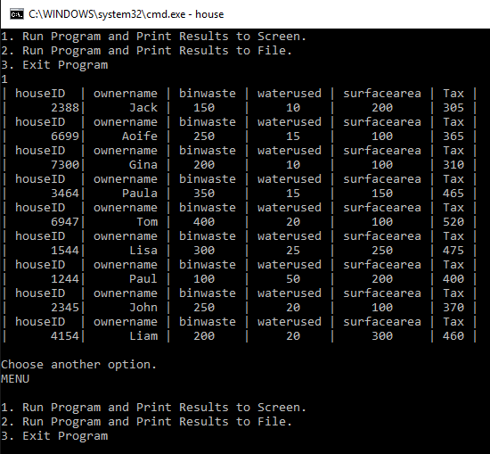

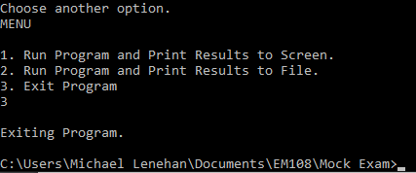Other menu options working

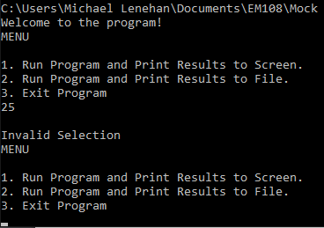Menu default working